PROJECT REPORT
Electric Vehicle Market Performance & Insights
Data Analytics with Tableau – Capstone Project

Submitted by: Riya Sharma
Medicaps University
Team ID: NA
November 2026

Dashboard: https://public.tableau.com/app/profile/riya.sharma8766/viz/ev_riya_final/EVTechnologyDashboard
Story: https://public.tableau.com/app/profile/riya.sharma8766/viz/ev_riya_final/Story1
GitHub: [Paste GitHub repository link]
Demo video: [Paste Google Drive demo video link]

1. INTRODUCTION
1.1 Project Overview
Electric vehicle adoption depends not only on sales but on technology – battery size, energy efficiency, charging time, motor power – and on ownership costs such as insurance. Stakeholders need to see these together with regional sales.
In this project I used the cleaned EV dataset (199,999 records, 37 attributes, model years 2018–2026) and built an EV Technology Dashboard in Tableau with a KPI strip, regional and technology charts, two extra analysis sheets and a 3-point story, published on Tableau Public.
1.2 Purpose
The dashboard answers the questions of three users:
• Emily Johnson (EV Market Strategy Director): needs to know which segments perform best, how battery size and efficiency differ by category, and where sales are growing, to plan the product portfolio.
• David Chen (Automotive BI Manager): compares regions, battery technologies, drivetrains and ownership costs so he can recommend markets and products to his clients.
• Dr. Sarah Williams (Sustainable Mobility Research Analyst): researches battery technology, energy efficiency and charging, and how they differ across regions and vehicle types, to guide clean-transport policy.
2. IDEATION PHASE
2.1 Problem Statement
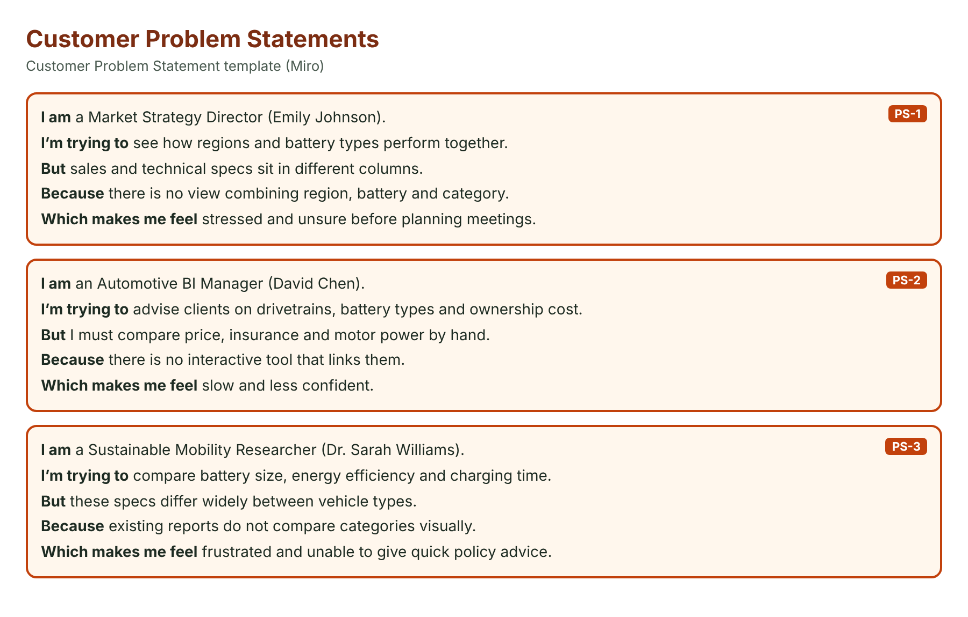
2.2 Empathy Map Canvas
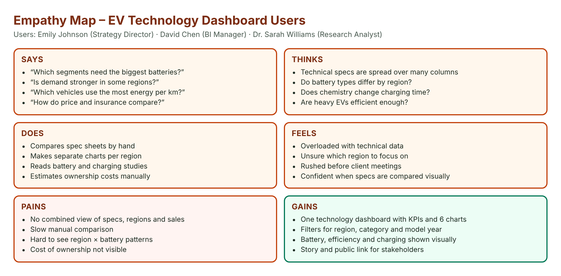
2.3 Brainstorming
Ideas were ranked by feasibility and importance. A regional sales dashboard with KPIs, technology views (battery, efficiency, charging) and cost/performance sheets with a story were selected; a mobile app was not selected.
3. REQUIREMENT ANALYSIS
3.1 Customer Journey Map
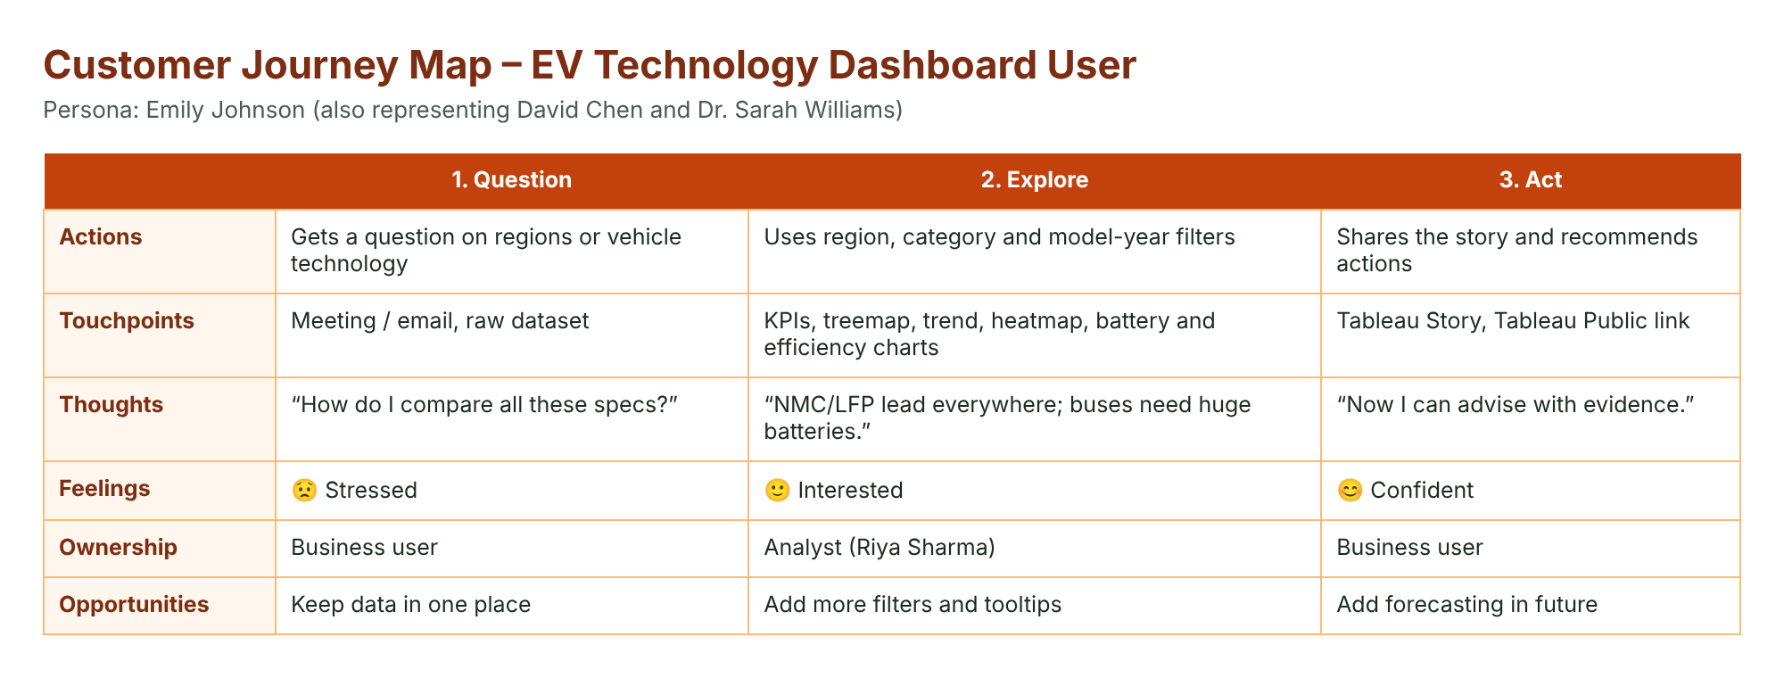
3.2 Solution Requirement
FR | Requirement | Description
FR-1 | Data access | Connect ev_market_clean.csv to Tableau as an extract
FR-2 | Data processing | Cleaned data; calculated fields
FR-3 | Analysis | SUM and AVG by region, category, battery type, drivetrain
FR-4 | Outputs | 9 worksheets, dashboard, story
FR-5 | Interaction | Region, category and model-year filters
FR-6 | Reporting | Tableau Public link

3.3 Data Flow Diagram
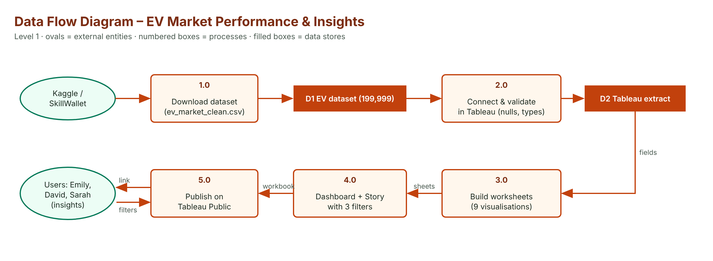
3.4 Technology Stack
Tableau Desktop / Tableau Public for building and publishing; cleaned CSV + Tableau extract for data; 7 Tableau calculated fields for KPIs; GitHub for files and documentation; Google Drive for the demo video.
4. PROJECT DESIGN
4.1 Problem Solution Fit
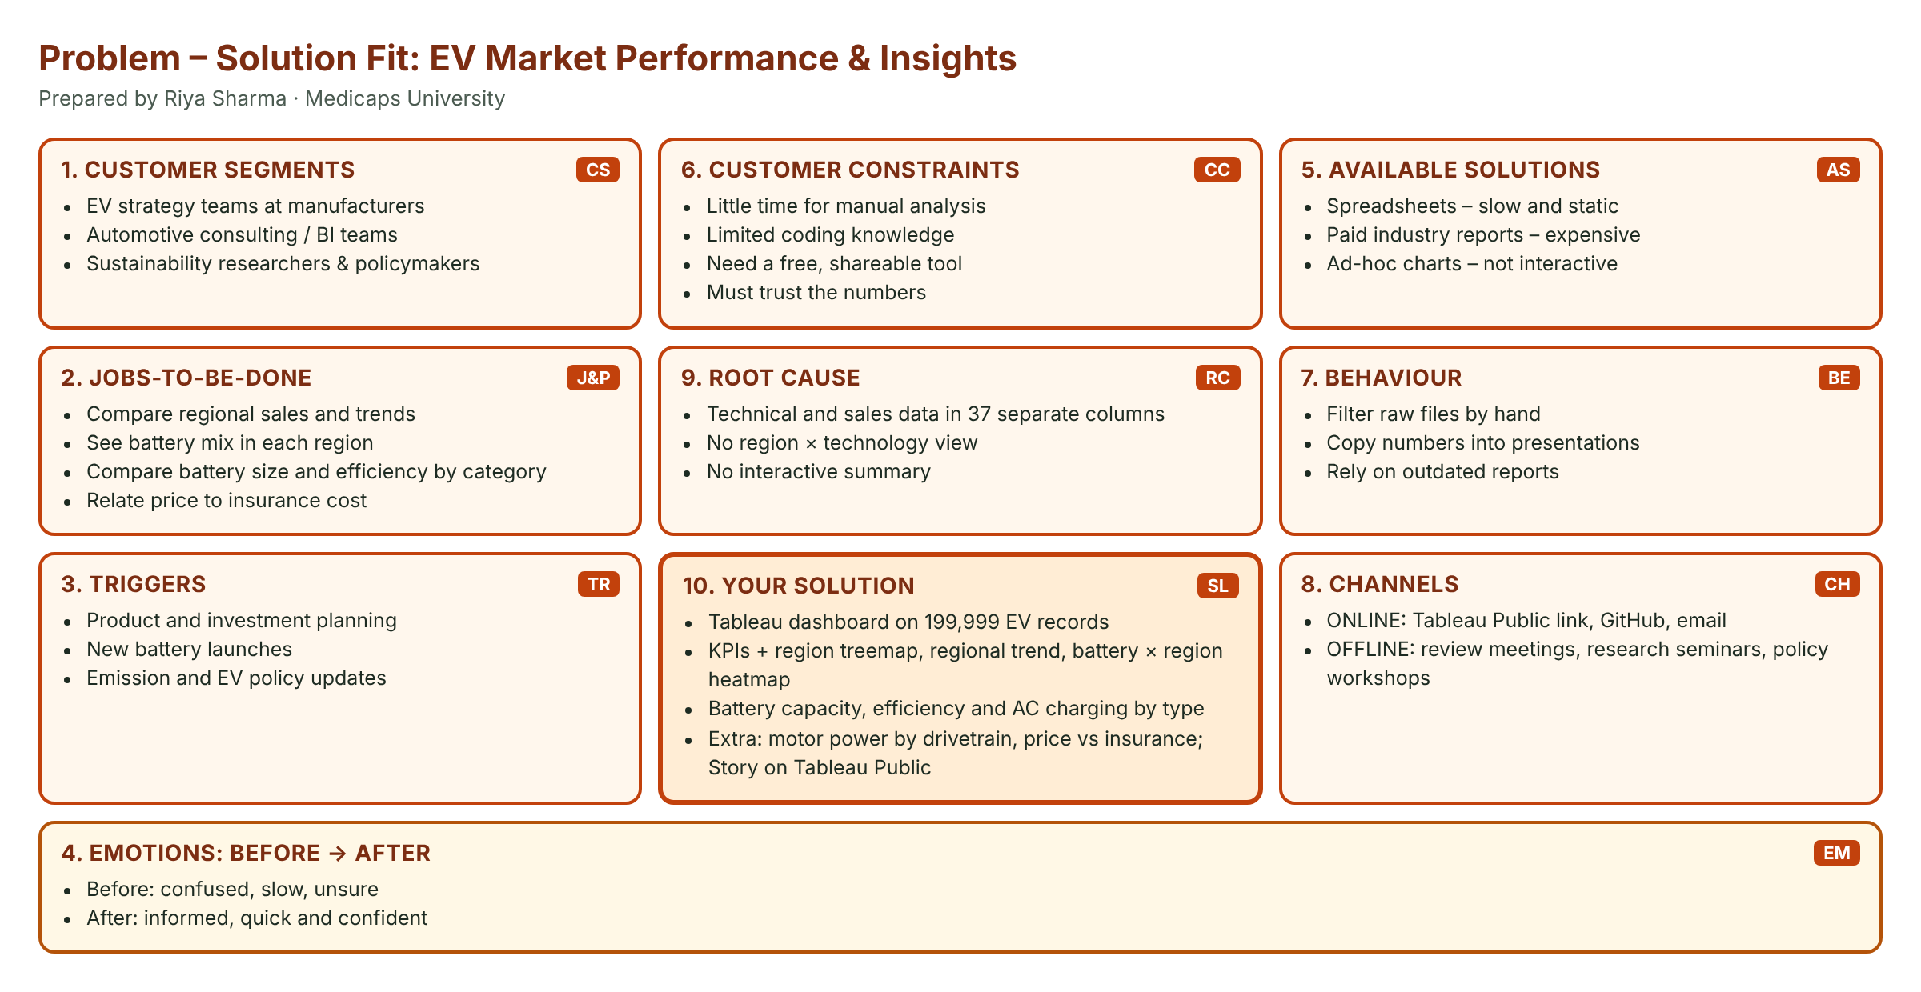
4.2 Proposed Solution
Cleaned data → extract → calculated fields → 9 worksheets → dashboard with 3 shared filters → story → Tableau Public → testing and documentation.
4.3 Solution Architecture
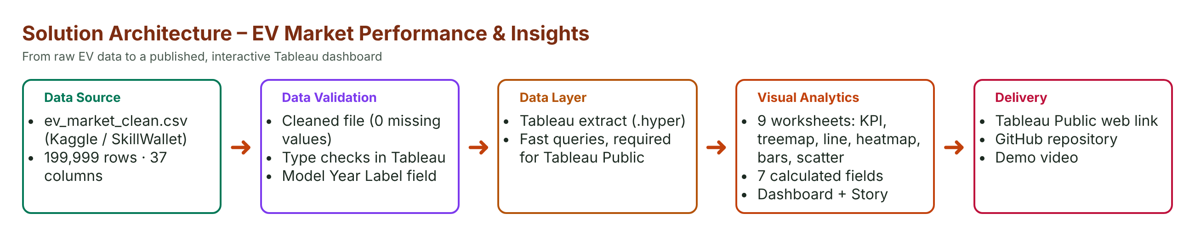
5. PROJECT PLANNING & SCHEDULING
5.1 Project Planning
19 user stories (48 story points) were completed in 4 one-day sprints between 30 October and 3 November 2026; average velocity 12 points per sprint.
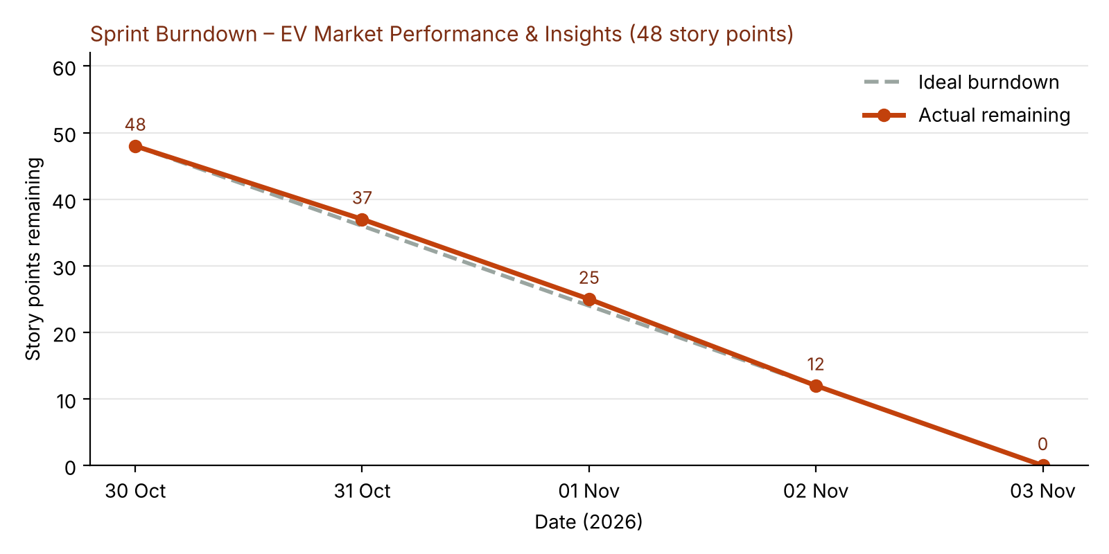
6. FUNCTIONAL AND PERFORMANCE TESTING
6.1 Performance Testing
Parameter | Values
Data Rendered | 199,999 rows × 37 columns + 7 calculated fields
Data Quality | 0 duplicates, 0 missing values
Filters | Market Region, Category, Model Year
Calculations | Total Sales (M Units); Avg Battery (kWh); Avg Motor Power (kW); Avg Efficiency (Wh/km); Avg Insurance (USD/yr); Avg AC Charge (hrs); Model Year Label
Dashboard | KPIs + 6 charts; 9 worksheets in total
Story | 3 story points

7. RESULTS
7.1 Output Screenshots
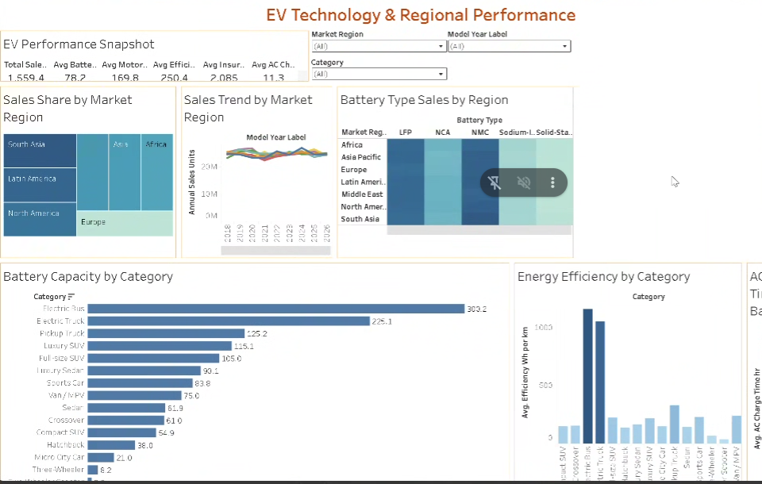
EV Technology Dashboard
1. EV Performance Snapshot
Question: What are the headline technical and sales figures of the EV market? (Scenario 1, 2, 3)
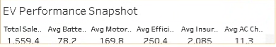
Insight: Total annual sales are 1,559.4 M units; an average EV has a 78.2 kWh battery and a 169.8 kW motor, uses 250.4 Wh per km, costs 2,085 USD a year to insure and needs 11.3 hours to charge on AC.
2. Sales Share by Market Region
Question: How is EV sales volume shared between market regions? (Scenario 2)
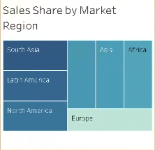
Insight: Every region holds about 14% of sales: South Asia (225.2 M units) and Latin America (224.7 M) are slightly ahead, Europe (218.8 M) is slightly behind – demand is balanced worldwide.
3. Sales Trend by Market Region
Question: How have sales in each region changed over model years 2018–2026? (Scenario 1, 2)
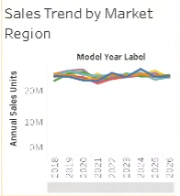
Insight: All seven regional lines move closely together; total sales stay between 166.7 M and 178.0 M units per model year, with peaks for 2019 and 2024 models – growth is steady in every region.
4. Battery Type Sales by Region
Question: Which battery technologies sell most in each region? (Scenario 2, 3)
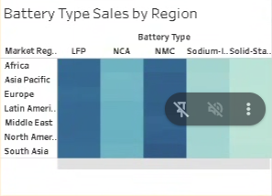
Insight: NMC and LFP are the darkest cells in every region (about 70–79 M units each), with NMC strongest in South Asia (78.5 M). Sodium-Ion and Solid-State are the lightest (15–23 M) – new chemistries are still small everywhere.
5. Battery Capacity by Category
Question: How large are the batteries in each vehicle category? (Scenario 1, 3)
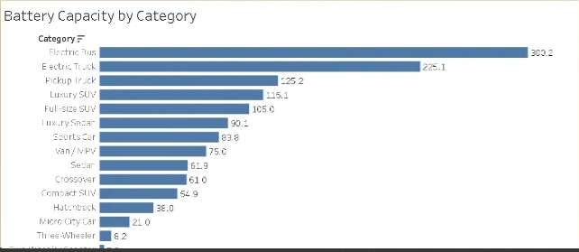
Insight: Electric Buses carry the biggest batteries (300.2 kWh), followed by Electric Trucks (225.1 kWh) and Pickup Trucks (125.2 kWh). Two-Wheeler Scooters need only 3.3 kWh.
6. Energy Efficiency by Category
Question: Which vehicle categories use the most energy per kilometre? (Scenario 3)
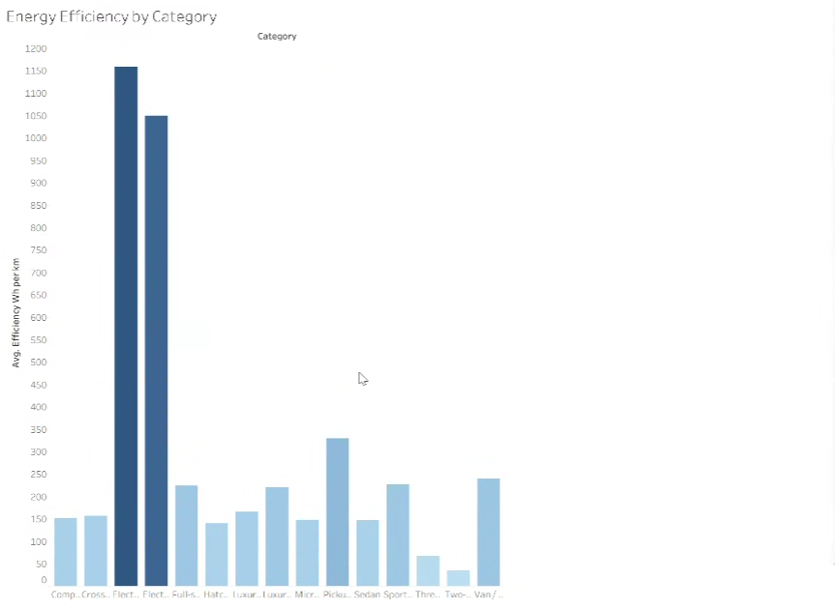
Insight: Electric Buses (1,159 Wh/km) and Electric Trucks (1,049 Wh/km) use far more energy per km than passenger cars (≈140–240 Wh/km), while Two-Wheelers use only 35 Wh/km.
7. AC Charging Time by Battery Type
Question: Does battery chemistry change AC charging time? (Scenario 3)
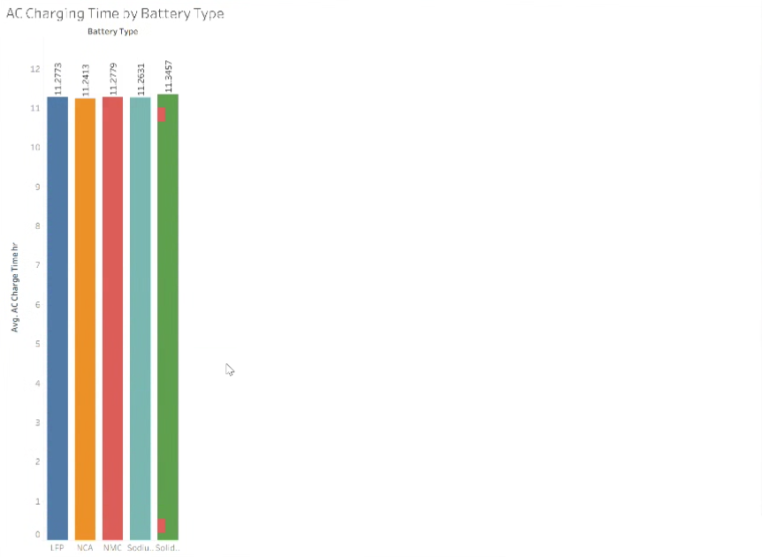
Insight: Average AC charging time is almost the same for every chemistry – about 11.2–11.3 hours (Solid-State 11.35 h, NCA 11.24 h). Charging time depends on battery size, not chemistry.
8. Motor Power by Drivetrain
Question: How does motor power differ between AWD, FWD and RWD? (Scenario 1, 2)
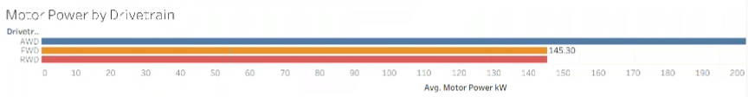
Insight: AWD vehicles have the most powerful motors (223.8 kW on average), about 54% more than FWD and RWD vehicles (145.3 kW each).
9. Price vs Insurance Cost
Question: How is vehicle price related to yearly insurance cost? (Scenario 2)
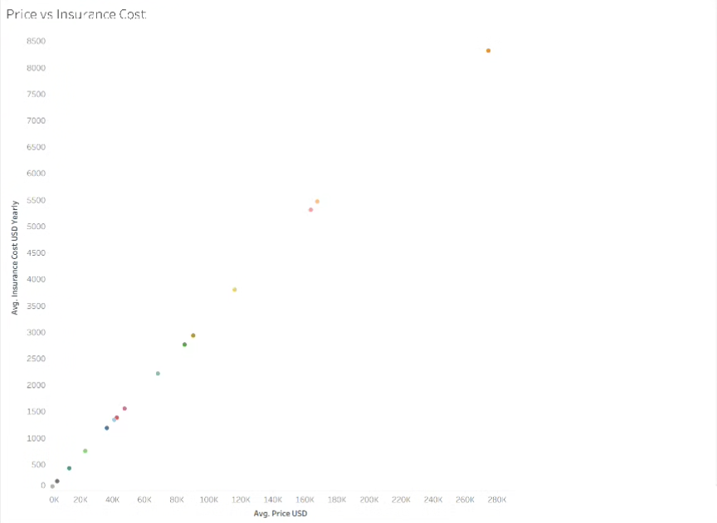
Insight: Insurance rises almost in a straight line with price (correlation 0.92): Two-Wheelers cost about 2,555 USD and 85 USD/yr to insure, while Electric Buses cost about 274,543 USD and 8,316 USD/yr.
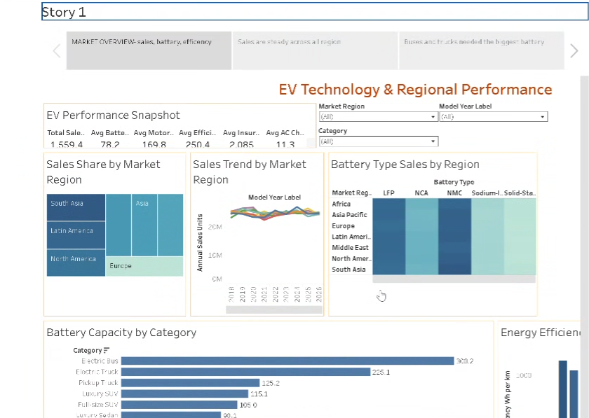
Tableau Story
8. ADVANTAGES & DISADVANTAGES
Advantages
• Combines sales, technology and cost in one dashboard.
• Three shared filters for focused analysis.
• Free and shareable through Tableau Public.
• Story makes findings easy to present.
Disadvantages
• Static data file, no live refresh.
• Some dashboard charts are small on laptop screens.
• No forecasting yet.
9. CONCLUSION
The EV Technology Dashboard shows that sales are evenly spread across the seven regions and steady over time, NMC and LFP are the leading batteries in every region, buses and trucks need by far the largest batteries and the most energy per km, AC charging takes about 11.3 hours whatever the chemistry, AWD vehicles have about 54% more motor power, and insurance cost rises almost linearly with price. These insights support Emily’s portfolio planning, David’s client advice and Sarah’s research.
10. FUTURE SCOPE
• Drill-down from region to country.
• Forecast sales by region.
• Live data with scheduled refresh.
• Total cost of ownership analysis.
11. APPENDIX
Item | Link
Dataset | https://www.kaggle.com/datasets/tharishreddy22/electric-vehicle-market-classification-dataset
Dashboard | https://public.tableau.com/app/profile/riya.sharma8766/viz/ev_riya_final/EVTechnologyDashboard
Story | https://public.tableau.com/app/profile/riya.sharma8766/viz/ev_riya_final/Story1
GitHub | [Paste GitHub repository link]
Demo video | [Paste Google Drive demo video link]

Data preparation:
• Used the cleaned EV dataset ev_market_clean.csv: 199,999 rows × 37 columns (prepared from the Kaggle / SkillWallet ev_market_train.csv file).
• Cleaning already applied to this file: 1 duplicate row removed and about 19,000 missing values filled with category medians, so it has 0 missing values.
• Checked data types in Tableau’s Data Source tab; created a Model Year Label field so model years work as categories.
• Created a Tableau extract (.hyper) so the dashboard is fast and can be published to Tableau Public.

